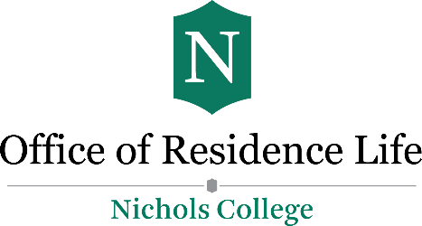
JOB DESCRIPTION: RESIDENT ASSISTANT
EMPLOYMENT TERM: 2025-2026

Position Overview:
Resident Assistants (RAs) play a key role in building a supportive and safe residential environment. RAs live in the residence halls, assist with community standards, and support student development through programming and mentorship. This position is for the 2025-2026 academic year, with employment covering August through May.

Key Responsibilities:
- Community Development:
  - Conduct monthly programs and events to foster engagement.
  - Complete three health and safety inspections per semester.
  - Hold regular floor meetings and maintain updated bulletin boards and door decorations.
- Availability & On-Call Duties:
  - Be on-call during specified hours in the evenings and overnight.
  - Conduct Active Connection Rounds (ACR) with Public Safety and Admin On Call during designated weekend nights.
  - Cover on-campus ACR two weekends per month and remain accessible Sunday-Thursday nights.
- Administrative & Team Meetings:
  - Attend weekly staff meetings, monthly all-staff meetings, and one-on-one meetings with supervisors.
  - Participate in opening/closing duties for breaks, semester transitions, and special events.

Employment Requirements:
- Minimum 12 credit hours per semester and maintain a 2.5 GPA.
- Approval required for additional on/off-campus jobs; limited to 12 hours for new RAs.
- RAs are not able to be Orientation Leaders.
- Adhere to Nichols College policies and maintain professional standards.
- Must be in satisfactory disciplinary status as determined by Director of Residence Life & Community Standards.

Evaluation and Rehire:
This is a one (1) year contract appointment. Performance is reviewed each semester, influencing eligibility for rehire or contract renewal.

Compensation:
RAs receive a credit applied to their room charge on their student account bill.

