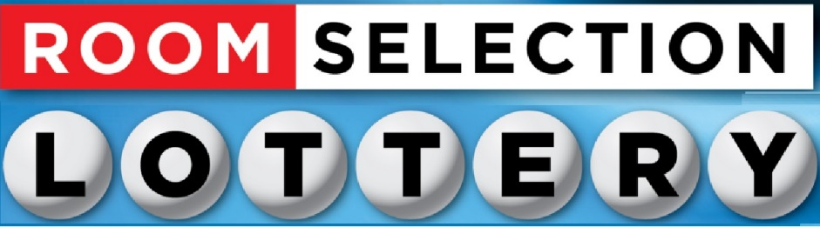

2022-2023 Room Selection Proxy Form

I authorize __________________________________________ to be my proxy for 2022-2023 Room Selection Process. I understand that the person name above will be choosing my Room.

I also understand that if myself or my proxy falsify this form in any way that we both may face conduct charges and be removed from our chosen room assignment.

Student Name___________________________________ ID Number____________________

Student Signature________________________________

Proxy Name_____________________________________ ID Number____________________

Proxy Signature__________________________________

Proxy Forms will be collected from your Proxy at the night of Room Selection by one of our Residence Life Staff Members. Failure to have a completed Proxy Form when your Group is called will result in you/your group being passed over, and may forfeit your position in the Selection Process.​

