How to Log on to the Housing Portal

Go to https://hub.nichols.edu/departments/residence-life and click the teal box “Click Here for the Housing Portal”

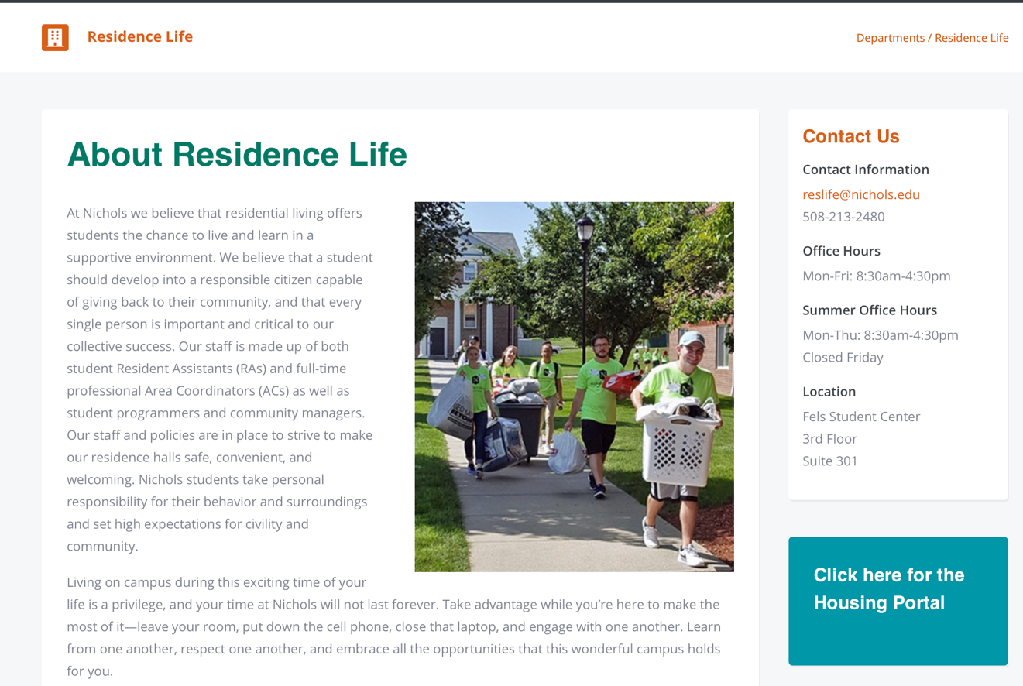

This will then take you directly to the Housing Portal (you may be asked to log into OneLogin using your credentials)
